Speedy Blupi Glitches
by jummy
Gameplay glitches
Bomb collision asymmetry
★ Glue recoil boosting
Glue recoil boosting: Extreme Edition
Lift object slot priority
Bottom ¼ block causes stuttering
Swimming in air
Remote bomb deployment
Delayed item count
★ Crate logic
Skateboard trap
Vehicles/transformations on springs
Falling through conveyor belts (SB2)
★ Uncleared crate flag (pulling crate into skateboard)
★ Skateboard duplication
Water softlock
SB1
SB2
Respawning inside a case
Respawning inside a hazard
★ Level exit cancel and layering problems
★ Glue death cancel
Speed conservation
★ High jump from bars
Interrupted teleport (SB2)
Teleport from water (SB2)
Invulnerability while dropping glue
Blocks using incorrect global timer (SB2)
Powercharge in water
Too much smoke (SB2)
Conflicting entity interactions
Y velocity disparity
Multiplayer entity disparity
★ Shared powerup energy
★ Long lightning (SB2)
Permanently broken bridge (SB2)
Demo recording desynchronization
Any version
SB2
Bonk storage
Ghost doors (SB2)
Inaccessible vehicles
Saw switch repeats its animation (SB2)
★ Skateboarding backwards
Stuck in water
Wind deletion game crash
Remote wind deletion
Multiplayer with different game versions
Out of bounds crash
Level editor glitches
★ Entities move like lifts (SB2)
★ Personal bomb on tank
★ Super secret blocks (SB2)
★ Vehicle enemy uses wrong graphics channel (SB2)
Menu and systematic glitches
Wrong level indexes cause false CD-Rom error
Any version
SB2
Game over overwrites wrong data
Any version
SB2
Game over warp
Multiplayer save/load
Multiplayer team colors in singleplayer
Custom level #10 acts different
Uninitialized memory values in save files
Save/load hotkeys close the game (SB DEMO v0.8)
OS compatibility glitches
Blue boxes
DirectPlay
Save files cannot be deleted
Game window is too short
Text encoding disparity
Level design mistakes
Impossible egg (SB2)
Bottomless pits
Aesthetic glitches
Animation timer overflow
SB1
SB2
Music contains silence
Demo sound continues indefinitely
References to "Blupi" regardless of version
Any version
Speedy Eggbert 2
Wasp sting preserves air gauge (SB2)
★ Left+right+down noise
Incorrect number of save files
Quicksave graphical inconsistency
Dream blocks are transparent (SB1)
Desynchronized demo (SB1 DEMO v0.8)
Shaking effect causes graphical errors (SB1 DEMO v0.8)
Incorrect save titles (SB2)
Untranslated menu (Russian SE1)
★ Spelling and grammar

Gameplay glitches

Bomb collision asymmetry
Floor bombs have very lenient collision on the left side.

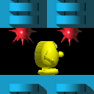
Top: Range of safe positions between two floor bombs.
Bottom: Range of safe positions between two hanging bombs.

★ Glue recoil boosting
In a helicopter or tank, firing a glue ball and holding the opposite direction quickly after firing allows the player to gain unbounded speed, as long as there's glue supply left.
Video 1
Video 2
Video 3
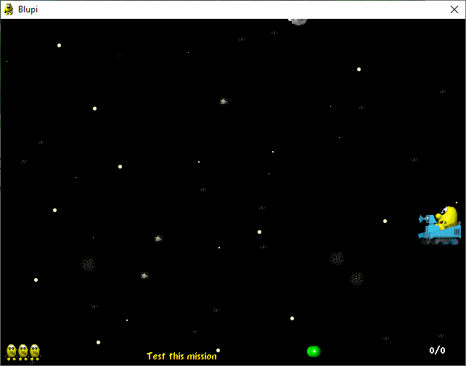

Glue recoil boosting: Extreme Edition
If glue is fired from a tank while all entity slots are full, the tank will receive the velocity boost on every frame without spawning or using any glue. A similar effect also occurs with the helicopter, but not on every frame.
Video

Lift object slot priority
Blupi prefers to stand on lifts with higher object slots. Even when standing still, he will always "transfer" to a lift of a higher slot if available. While not strictly a bug, it can cause strange behaviors, such as passing through the tops of lifts.

Bottom ¼ block causes stuttering
Jump on a block with bottom ¼ solidity (i.e. an upwards Fan). Blupi may occasionally teleport above the floor, and stutter in place.
This also affects blocks with bottom ¾ solidity, although none normally exist.
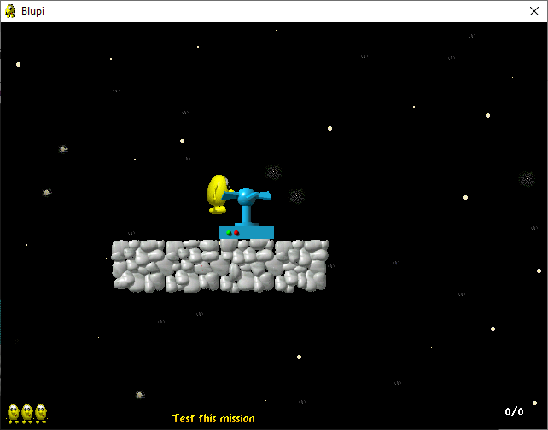

Swimming in air
If Blupi exits water into another block's bounding box (such as the T-shaped special tech block), he will continue swimming until reaching a fully non-solid block.
Video
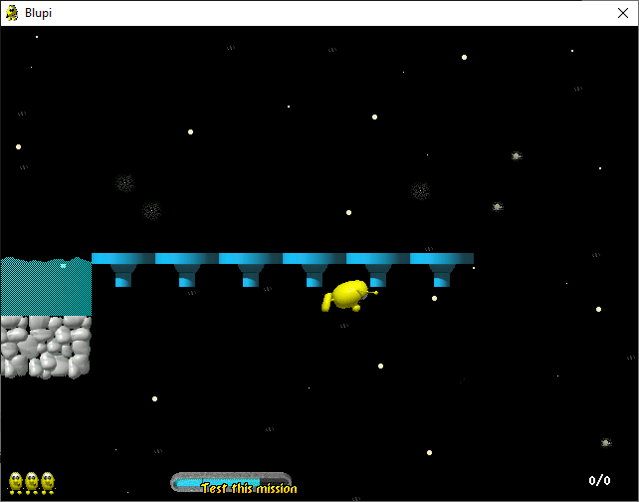

Remote bomb deployment
If a Personal bomb is placed on the same frame that Blupi dismounts a vehicle, the vehicle's velocity will be erroneously applied to the bomb's position. Combined with "Glue recoil boosting", bombs can end up in places they shouldn't be able to, such as inside solid walls.
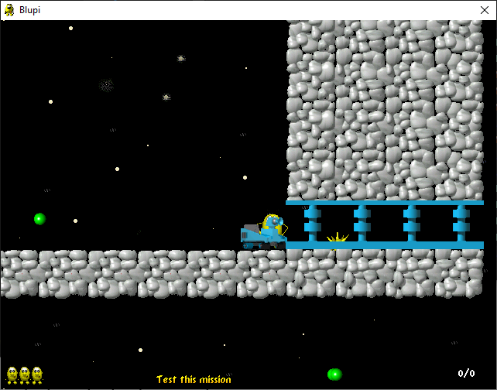

Delayed item count
When collecting an item, it isn't considered to be in the player's possession until its animation is completed. This can have the following effects:
- Levels cannot be completed until the final chest is counted
- Doors cannot be opened until the corresponding key or chest is counted
- Dynamite cannot be deployed until it is counted
- An 11th extra life can be collected before the 10th life is counted
- A 6th personal bomb can be collected before the 5th bomb is counted
This does not occur in the Training level (world010), or any custom level #10. See also "Custom level #10 acts different".
Video
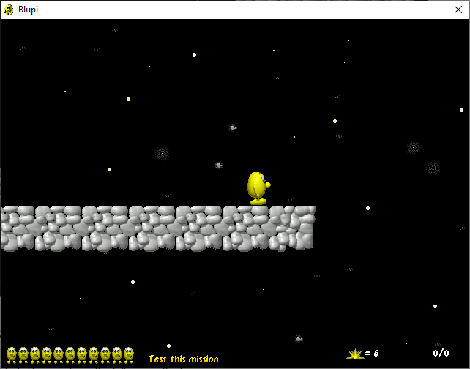

★ Crate logic
- Crates are generally prevented from leaving their stack and floating, however certain setups can cause floating crates regardless.
Video
- Jumping towards a crate while holding down can allow Blupi to get closer to the crate than normal. Tapping the direction away from the crate to pull it as lightly as possible can cause it to move away from Blupi. This can be abused to move crates closer together than normal.
- Using the above method to pack at least 4 crates together, Blupi can pull the crates over himself and (in SB2) trigger wall ejection.
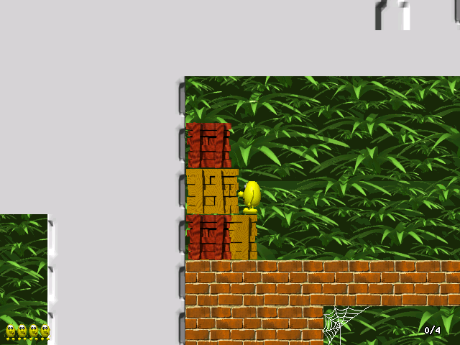
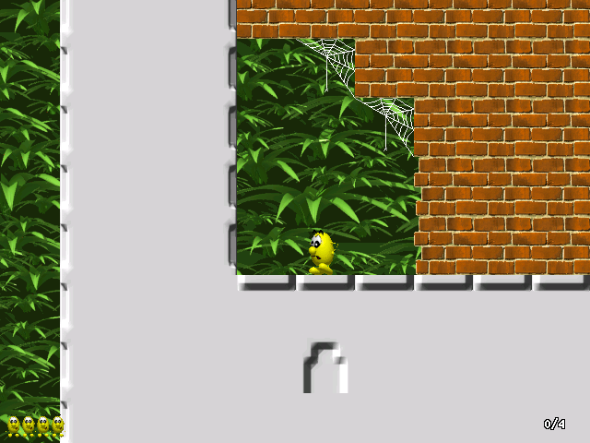
Top: 5 crates packed too close together. Pressing left will cause ejection.
Bottom: after ejection.

Skateboard trap
Placing a skateboard on top of a spring will create an inescapable trap.
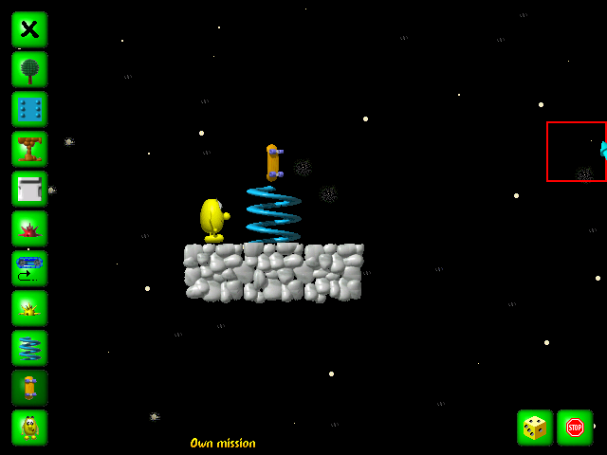

Vehicles/transformations on springs
If Blupi has a shield and rides a vehicle onto a spring, he will bounce in strange ways (except for skateboard, which behaves fine aside from the "Skateboard trap"). This also happens with SB2's "flattened" and "stung" transformations, neither of which require a shield.

Falling through conveyor belts (SB2)
Conveyor belts have very bad collision, and Blupi will often fall through them when standing on the edge.

★ Uncleared crate flag (pulling crate into skateboard)
Video
Pulling a wooden crate into a skateboard can cause the game to mistakenly remove the crate instead of the skateboard pickup. Any object that loads into this slot will have solidity like a crate, which can get Blupi stuck in place (SB1) or eject him through the floor (SB2). In custom levels, this slot is often filled by the skateboard when dismounted (due to the lack of other objects), but any object can fill the slot. This bug's effects can be difficult to anticipate due to the obscure nature of object slots.

★ Skateboard duplication
If Blupi rides a lift away from a skateboard while picking it up, he will be given a skateboard without the item disappearing. In some cases this can delete other objects, including the lift.
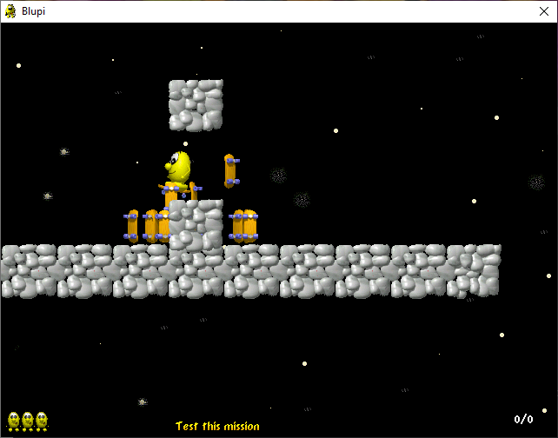

Water softlock

SB1
Exiting water from the side while too close to a floor or ceiling can cause Blupi to become stuck. This can happen in Mech 4. Video

SB2
Partially fixed. Exiting near a ceiling no longer causes the bug but exiting near a floor still does. Additionally, no official SB2 levels contain water in this configuration.
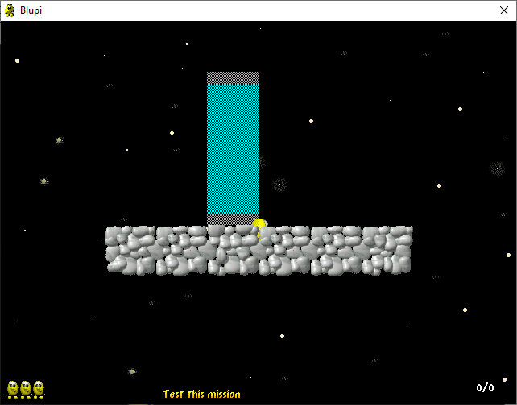

Respawning inside a case
A case can move onto Blupi's checkpoint. If Blupi dies (in lava) and uses the checkpoint, he will become stuck (SB1) or ejected through the floor (SB2). This is common in the Final level of SB2, which can cause the player to lose uncontrollably!

Respawning inside a hazard
After losing a life to a bomb, Blupi will fall straight down, which may make him fall into lava or other hazards, unavoidably losing another life.

★ Level exit cancel and layering problems
Certain events can take Blupi out of the "winning" state, such as bumping his head or landing in lava. He will not complete the level until the animation is allowed to complete. This may be intentional, but it also causes Blupi to appear in front of blocks.
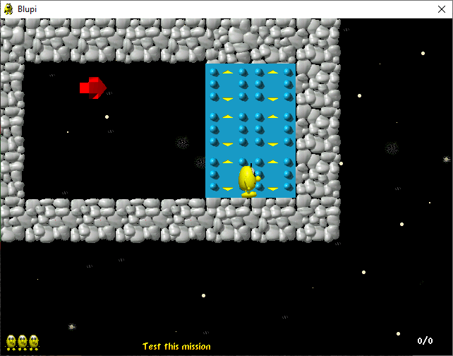

★ Glue death cancel
If Blupi hits a ceiling with enough vertical speed while firing glue from a helicopter, he may be hit by his own fired glue, but will cancel the animation to shake his head when he hits the ground.

Speed conservation
In specific cases, Blupi can conserve velocity between states which normally reset his velocity.
- If Blupi collects a helicopter while standing on invisible blocks, he will be propelled downward with the velocity at which he landed from his previous fall.
- If Blupi respawns in water, he will keep his speed from before he died. Video

★ High jump from bars
By pressing Up, Down, and Ctrl while hanging onto a bar, the player can perform a full, 4-block high jump rather than the usual sub-1-block jump. On a gamepad (where up and down can't be pressed together), this can be achieved by precisely timing a jump after pressing down.
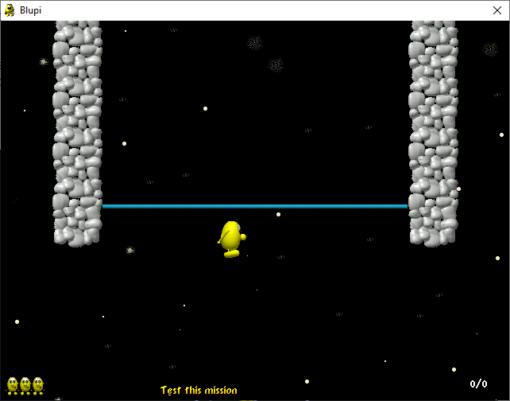

Interrupted teleport (SB2)
If Blupi is moved by a lift during the teleport animation, or if there is no corresponding exit teleporter, the teleport will be cancelled and Blupi will repeat the animation until the player moves. If Blupi is moved under a different teleporter, he will use it instead.
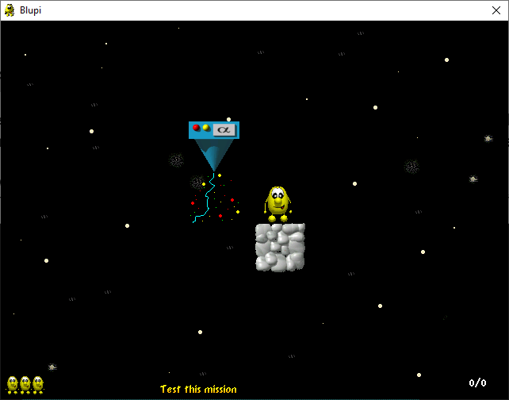

Teleport from water (SB2)
If Blupi uses a teleporter that's immediately above water, the teleport will function correctly but Blupi's animation will repeat until the player moves. If a teleporter is one block above the water, a similar effect will happen, but Blupi will be moved up to the teleporter in a swimming animation.
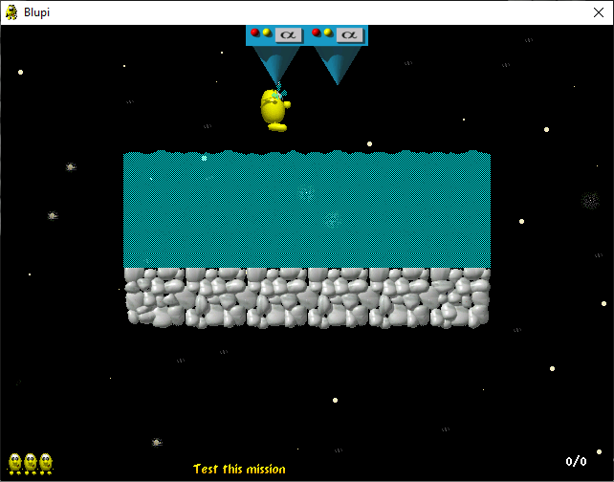

Invulnerability while dropping glue
When dropping glue from a helicopter, Blupi becomes invulnerable to explosive damage for a fraction of a second.
Video

Blocks using incorrect global timer (SB2)
Lightning, vanishing blocks, crushers, and ceiling slime traps all operate on a global timer that is separate from the game logic. Thus, the player can press Pause-Break or use double speed mode and these blocks will continue to operate at normal speed.
This has an additional, smaller effect wherein Lightning blocks make a sound when loaded on the quicksave or design screens.
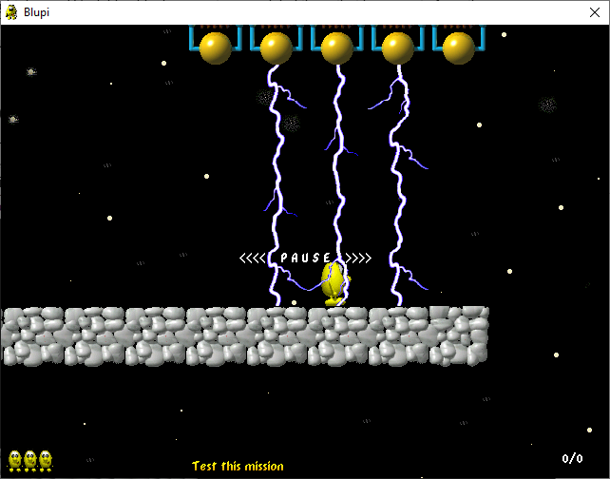

Powercharge in water
Blupi is meant to lose the powercharge effect when entering water, but this often doesn't happen as it only works when entering the surface of the water at specific y-velocity values.
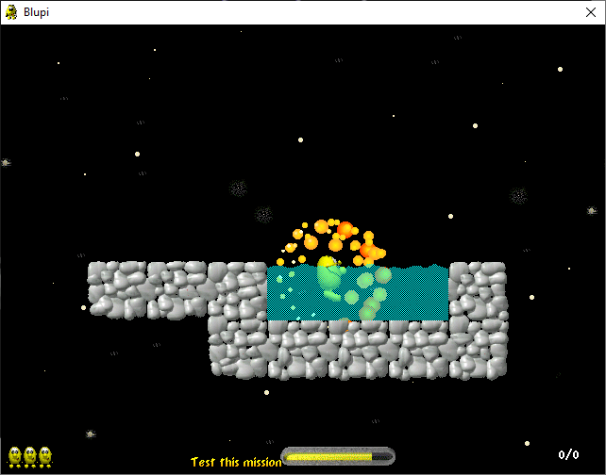

Too much smoke (SB2)
The smoke created from dying to lava will continue to spawn while the game is paused (by the Pause-Break key, not Esc). This provides an easy way to fill up all 200 entity slots, and potentially cause other bugs.
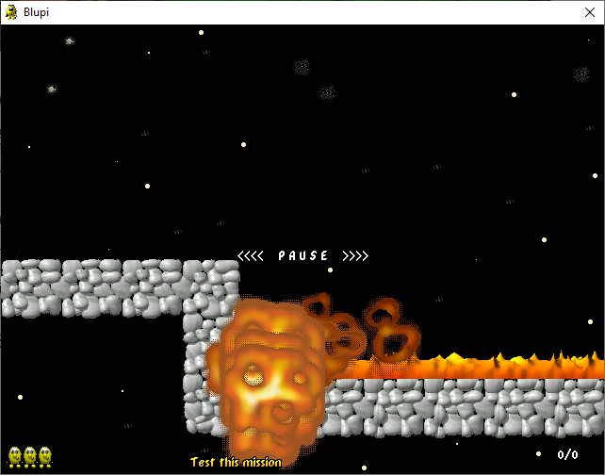

Conflicting entity interactions
In most cases, Blupi can only interact with one entity at a time. This has effects such as being unable to push a crate while touching an item, or being invulnerable to moving bombs while standing next to a floor bomb.
Video
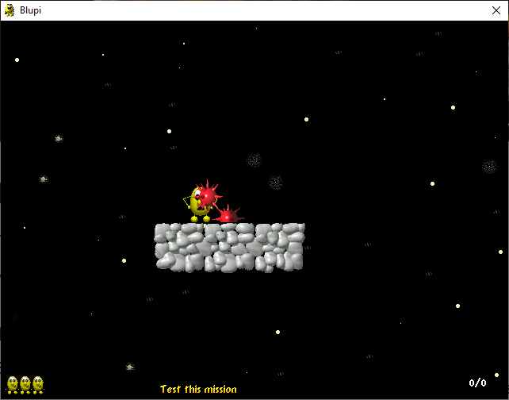

Y velocity disparity
Blupi's terminal velocity is higher when walking off a ledge (21 yv units = 42 px/frame) than jumping off a ledge (20 yv units = 40 px/frame). This is because Blupi's Y velocity stops increasing at 20, but his acceleration from gravity is 2 per frame. Thus, if the velocity is an odd number, it will increase from 19 to 21 in a single frame, and only then stop increasing.
Video

Multiplayer entity disparity
Due to each client's game running independently with no central server, entities can be falsely duplicated or deleted. The effect is more common if a player's game is loading or paused.

★ Shared powerup energy
Certain combinations of powerups can be stacked. Both effects are active, and the energy meter depletes more quickly.
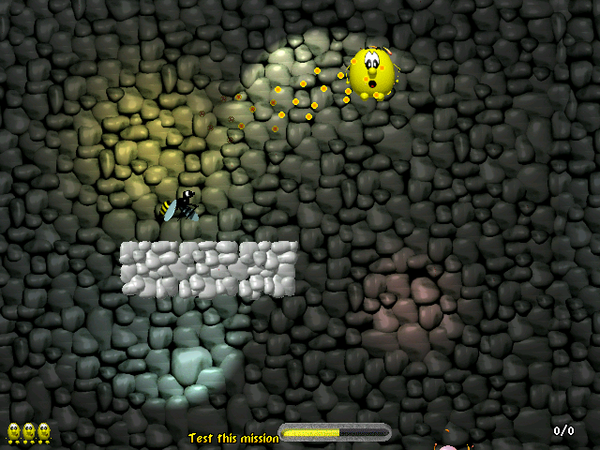
Wasp sting and Shield powerups active at the same time.

★ Long lightning (SB2)
Placing a Cave or Cheese block next to a Lightning machine, then deleting the machine, will cause the lightning to stay. This can be used to make longer lightning, or lightning without a machine.
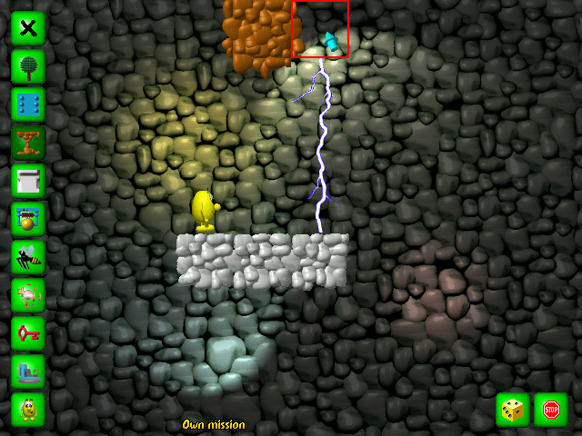

Permanently broken bridge (SB2)
If a fragile bridge is blown up with dynamite while it is falling, it will become frozen and never move again.
Video 1
Video 2

Demo recording desynchronization

Any version
- Recording a Demo movie is not perfect, and does not always match the player's input.
- Unfocusing the window during Demo playback can cause the Demo to miss button presses.

SB2
- Because SB2's death animations are random, a Demo will always desynchronize if the player loses a life.

Bonk storage
If Blupi lands on a skateboard after a hard collision with a ceiling, the "headache" animation will be delayed until jumping again. See also "Glue death cancel".

Ghost doors (SB2)
If blocks 01B9 to 026C are placed in a level through external editing, despite their graphics and collision being undefined, they will creak like a door when 21 to 200 chests are collected. This is caused by a lack of bounds checking in the code that handles chest doors; any block with an ID of 01A5 or higher will be handled like a chest door, including those beyond the intended maximum of 01B8. This is theoretically true for block IDs 0267 to 7FFF as well, but the entity limit (200) prevents so many chests being collected.

Inaccessible vehicles
Dismounting a vehicle at an X position of −1 will render it permanently inaccessible. See also "Saw switch repeats its animation".

Saw switch repeats its animation (SB2)
Using a saw switch while Blupi is at an X position of exactly −1 will cause Blupi to repeatedly toggle the switch. The player cannot jump or turn around in this state, and can only cancel the effect by walking in the direction Blupi is already facing. See also "Inaccessible vehicles".

★ Skateboarding backwards
While riding a skateboard, Blupi can change direction in midair and proceed to move in the original facing direction. This causes Blupi to appear to be skateboarding backwards.

Stuck in water
If Blupi falls at terminal velocity into one block of water at the very bottom of the world, he may become stuck in the lower world border and be forced to drown.

Wind deletion game crash
When destroying a fan that is blowing into the left edge of a level, the game may sometimes crash as it tries to read unintended areas of memory.

Remote wind deletion
If a fan is blowing wind into the bottom of the level, blowing up the fan will delete the wind in front of it and one block of wind at the top of the level, one block to the right (if any exists).

Multiplayer with different game versions
Any version of Speedy Blupi or Speedy Blupi 2 can connect to the same multiplayer session. However, some levels have different layouts between versions, some levels don't exist in SB1, and any SB2-specific animations will crash an SB1 client.

Out of bounds crash
If Blupi's Y position value is too great (approximately 5 million or more), the game may crash. This can occur in the mission test phase if Blupi drives a tank into a bottomless pit for approximately 45 minutes (90 minutes in double speed mode). Since there is no game over screen while testing the level, Blupi continues to fall below the screen.

Level editor glitches

★ Entities move like lifts (SB2)
Place a conveyor belt over an entity. The entity will move like a conveyor belt. This bug is not present in SB1 due to the lack of conveyor belts, but entities created in SB2 can still move in SB1.
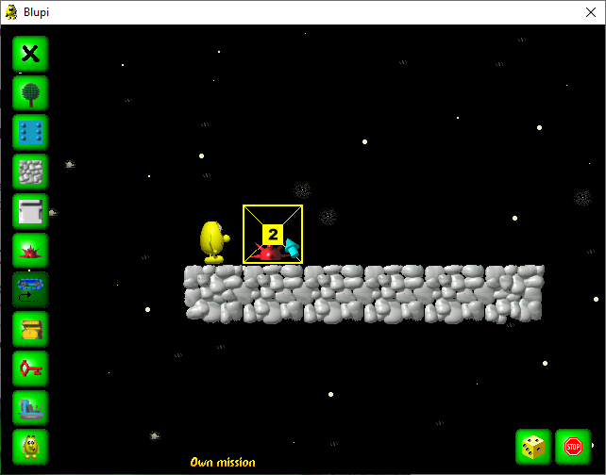

★ Personal bomb on tank
Place a personal bomb on a tank (or glue, invisibility potion, dynamite). When the player clicks the entity, its entity type increases by 1. After many clicks, the entity will become a personal bomb and return to normal.
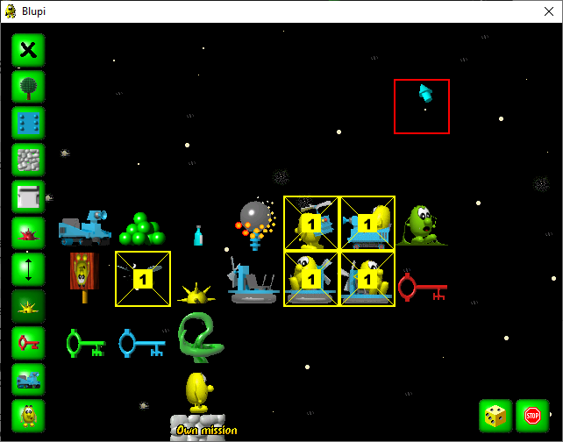

★ Super secret blocks (SB2)
Perform the "Personal bomb on tank" bug until the entity becomes a motionless bomb. This is a dummy entity with no behavior. Place a conveyor on the bomb, and it will become a non-solid object with the appearance of a lift. Every click changes the appearance.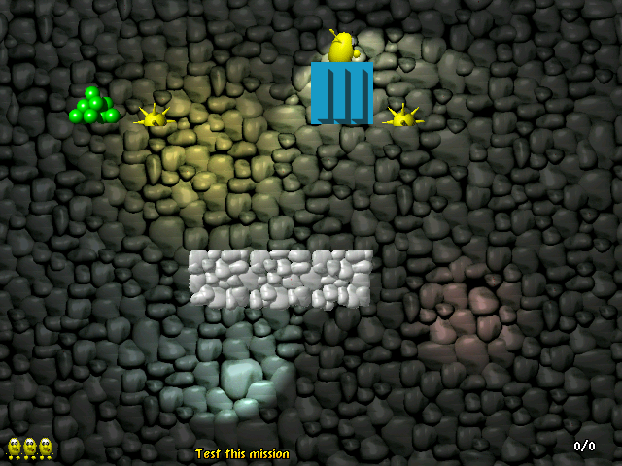

★ Vehicle enemy uses wrong graphics channel (SB2)
Perform "Entities move like lifts" on a vehicle enemy. The enemy turns into a mess of objects (channel CHOBJECT). Click again, and the enemy becomes a yellow Blupi (channel CHBLUPI). Click again, and the game crashes due to division by 0, because graphics channel CHBACK has 0 icons.
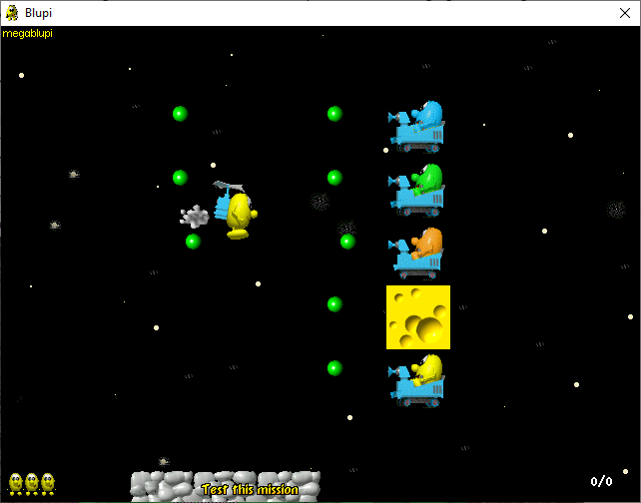

Menu and systematic glitches

Wrong level indexes cause false CD-Rom error

Any version
Lose all lives in the Start level (world001). The game tries to load world000, which does not exist. _EGAMES builds return to player selection (gamer.blp). Non-_EGAMES builds show a false CD-Rom error (insert.blp). _DEMO builds terminate immediately. A more severe form of this bug exists in Planet Blupi as of v1.14.2.

SB2
Lose all lives in the Final level (world199). The game tries to load world190, which does not exist.
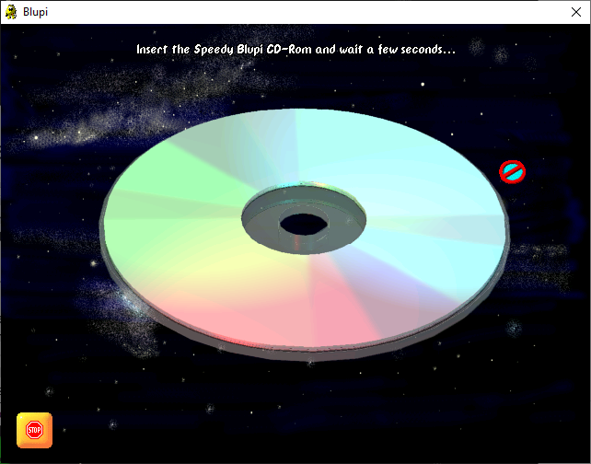

Game over overwrites wrong data

Any version
Start a multiplayer game. Press F3 and save. Exit the multiplayer game and open the save in singleplayer. Lose all lives. The flags in the user data are indexed out-of-bounds, and the wrong data is set to 01. In SB1, lives are set to 65537 (Video). In SB2, lives are set to 16777217, causing extreme CPU usage.
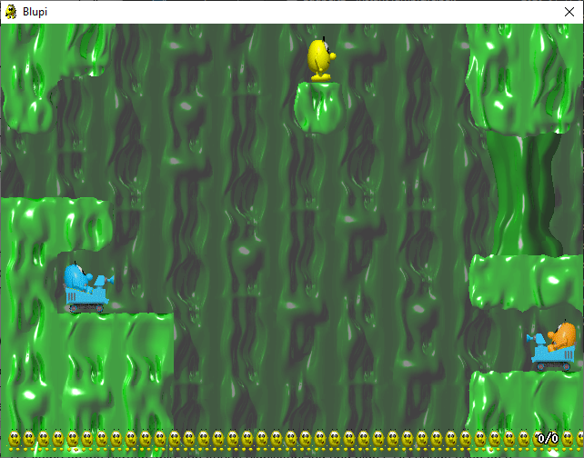

SB2
Losing all lives in the Final level (world199) locks three doors. The levels Bricks #5, Technical #5, and Rocks #7 must be completed again to unlock the doors.

Game over warp
Lose all lives. On the "lost" screen, press Enter. The custom level list appears, selecting the ID of the return level (for example, dying in level #43 will show level #40). Press Enter on any level to play. Progress made in this way will affect your save file, as if you had selected the level from the singleplayer hub. With "Multiplayer save/load", the player can complete the final level early.
Video 1
Video 2
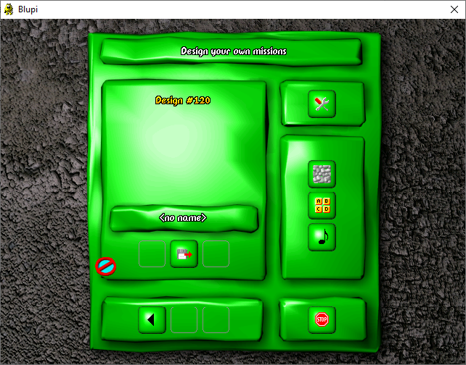

Multiplayer save/load
Saving and loading are disabled in multiplayer. However, the F3/F4 keys still work.
Video
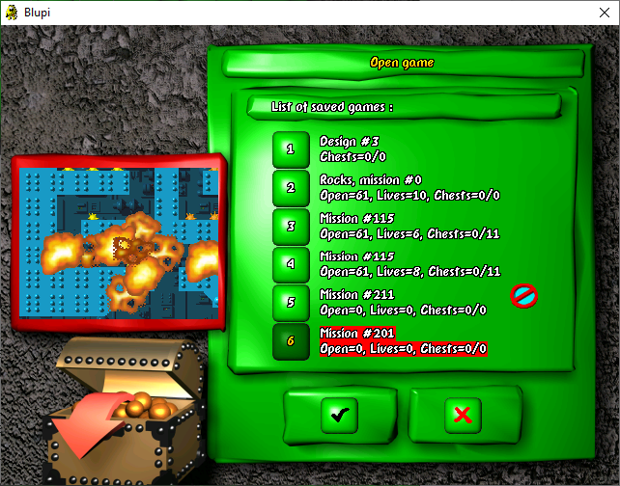

Multiplayer team colors in singleplayer
Play a multiplayer game as blue, orange, or green. Return to singleplayer. Personal bombs will act as in multiplayer. Yellow bombs kill the player, and new bombs change to the player's team.
Video
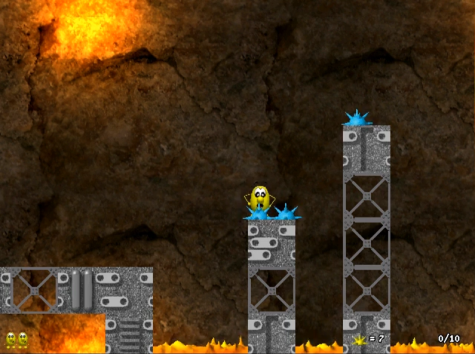

Custom level #10 acts different
Play any custom level #10. The level acts like the Training level (world010), so collected chests disappear instantly.
Video

Uninitialized memory values in save files
The user data files (info00x.blp) contain uninitialized data from the DescInfo struct (reserve1, reserve2, and the remaining space for the player name).

Save/load hotkeys close the game (SB DEMO v0.8)
Although the pause menu's save/load buttons are unavailable in this version, the F3/F4 hotkeys still work. However, the unmodified demo lacks the required image files (gwrite.blp and gread.blp), and will close. If these image files are present, the save/load menus function as in the full game. The game closing is likely an intentional failsafe which is only active in demo versions.

OS compatibility glitches

Blue boxes
Transparent graphics are not properly masked in desktop color modes higher than 16-bit (65,536). This primarily affects windowed mode, and can be fixed by changing the color mode to 16-bit in the EXE's compatibility settings.

DirectPlay
DirectPlay is no longer enabled by default with newer versions of Windows, and must be enabled manually from the Windows control panel.

Save files cannot be deleted
The game expects administrative write access, and may be unable to delete save files in a write-protected folder (such as Program Files).

Game window is too short
If the game is run in windowed mode (at least on Windows 10), the dimensions of the inner window will be 640×477 pixels rather than 640×480. This causes visual artifacting when moving the mouse. This is likely a regression with DirectX, as the game properly initializes the dimensions to 640×480, but only looks correct if initialized as 640×483.

Text encoding disparity
The appearance of accented letters (áéíóú, etc.) depends on the system locale. For example, in a Japanese locale, the accents are removed, and the letters are plain.
Furthermore, in recent versions of Windows (likely 10 and 11), there is a Control Panel setting titled "Beta: Use Unicode UTF-8 for worldwide language support". Enabling this setting can cause accented letters in Speedy Blupi to appear as squares.
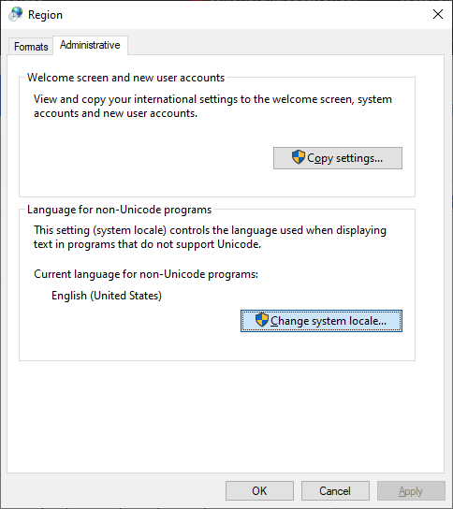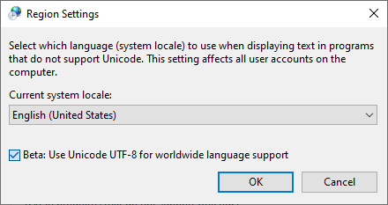
The relevant Control Panel settings in Windows 10 version 22H2.
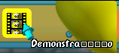
Portuguese text corrupted by the "Beta: Use Unicode UTF-8 for worldwide language support" setting. The word "Demonstração" appears as "Demonstra□□□□o".

Level design mistakes

Impossible egg (SB2)
SB2's Tech 4 contains an egg which is impossible to collect.
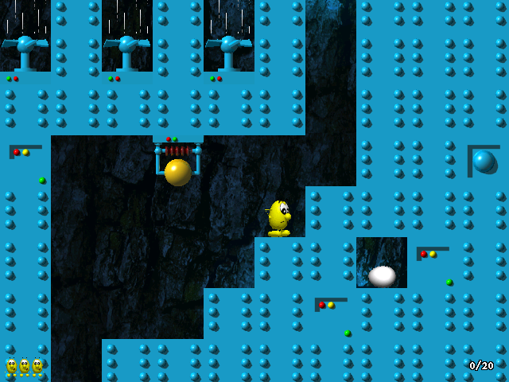

Bottomless pits
Some levels have design errors which allow the player to fall into a bottomless pit and game-over instantly. SB1's Houses 2 and Dream 5 levels have direct paths into the void. It's possible to fall into the void in SB2 due to glitches, but not level design errors.

Aesthetic glitches

Animation timer overflow

SB1
Play a level for 32768 frames (about 27 minutes). For some entities, their animation timer overflows to -32767, causing graphical corruptions. After 27 more minutes, the timers reach 0 and return to normal.
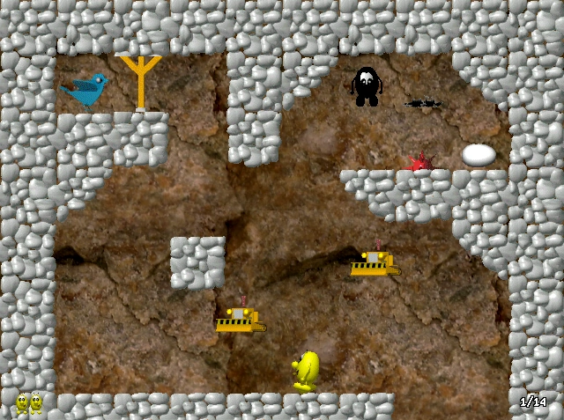

SB2
Only partially fixed. Entity timers ≥ 32700 are set to 0. This causes animation to briefly stutter before returning to normal.

Music contains silence
Music #1 and Music #7 (music000.blp and music006.blp) contain several minutes of silence at the end of the song.

Demo sound continues indefinitely
If a looping sound effect (vehicle engine) plays at the end of a Demo movie, the sound will continue through the next movie.
Video

References to "Blupi" regardless of version

Any version
In the Eggbert versions of the game, the window title is still "Blupi".

Speedy Eggbert 2
The Blupi statue palace decor still reads "BLUPI".

Wasp sting preserves air gauge (SB2)
If Blupi is stung by a wasp while underwater, the air gauge will stay visible if Blupi leaves the water, even after the wasp sting wears off. This effect is purely visual.

★ Left+right+down noise
Pressing left, right, and down at the same time will play an otherwise-unused sound. Alternatively, the player can make a quicksave while ducking and load it to play the sound. It is the duck sound effect in reverse, and may have been intended to play when letting go of the down arrow after ducking.
Video

Incorrect number of save files
Several official sources state that Speedy Blupi allows ten save files, despite the game only allowing eight. Phase Events exist and function properly for the 9th and 10th save files, but the corresponding menu buttons are not present. This is likely due to lack of screen space.

Quicksave graphical inconsistency
If Blupi's frame of animation is from a graphics channel other than blupi000 (CHBLUPI), the quicksave preview will use a frame from blupi000 instead.

Dream blocks are transparent (SB1)
In some graphical modes, the dream blocks' magenta color is falsely interpreted as transparency, causing trail effects.

Desynchronized demo (SB1 DEMO v0.8)
One demo recording was made on an earlier version of the game. It does not follow its intended path, nor does it complete the level. The demo was fixed for the final build of Speedy Blupi.

Shaking effect causes graphical errors (SB1 DEMO v0.8)
The shaking explosion effect can move the camera out-of-bounds, and causes graphical errors. This is fixed in the final build of SB1.

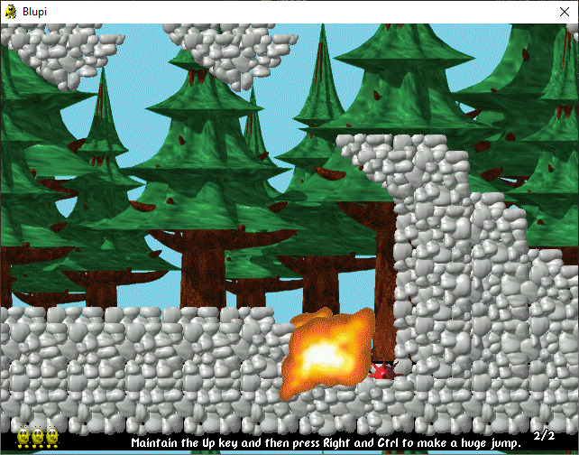Incorrect save titles (SB2)
The save menu wasn't updated for SB2. Many worlds have incorrect names.

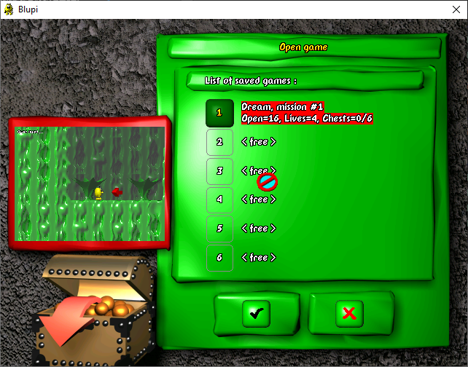

Untranslated menu (Russian SE1)
In Reaktivny Egbert (Russian Speedy Eggbert), one variant of the multiplayer connection protocol screen (service.blp) was left untranslated, showing gibberish text as the game displays English text in a Cyrillic character set. Additionally, the list displays text from the Windows API, which can do the same thing.
Screenshot of English text from the Windows API, displayed with Cyrillic letters. From a now-deleted YouTube video, "«Реактивный Эгберт». Честный обзор", courtesy of user "14AN'S xQC".

★ Spelling and grammar
Working as intended :)

